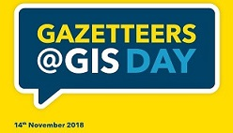

*Written by A.Bollella*

*In an era where acronyms seem to have a better life than words, we often ask ourselves what is the meaning of them or why we use them. As we step foot into the discovery, the question comes up pretty obviously: what is this* ***GIS Day*** *that everyone is talking about? It is a celebration day to remind ourselves the importance of Geographic Information Systems (a.k.a GIS!) and what they are used for.*

*Nowaydays we tend to take geograghy for granted due to the advanced technologies in our hands on a daily basis: think about your smartphone equipped with GPS (Global Positioning System) and interactive maps. Everything is at the disposal of your finger tips and no one gets lost (except for my best friend Valentina who has no clue what so ever how to use a map!). Every time she has to go somewhere out of her local area, she tends to get out of the house at least 3 hours before because she says (and I quote): “I need to have enough time to get lost to find my way!” (Lol!).*

*That’s when GIS Day comes in very handy. The first formal celebration was held on November 19 of 1999 and it was actually the National Geographic Society, Association of American Geographers (AAG) and Environmental Systems Research Institute (Esri), who really put the day into action. In other words, it was the perfect excuse for students, families and community members focus on the importance of geography by hosting events; using lessons, games, and challenges in the classroom; and often meeting with policymakers and business leaders as part of that year’s activities.*

*We all live our lives geographically. Planet Earth is our home. It is awesome, diverse, inspiring and ever changing. Studying geography invites us to participate more fully in the excitement, enjoyment and challenge of this dynamic world. It draws on personal experience, to help us better understand the places we live in, why they matter and how they are connected to a globalised world. Geography draws from across the physical, cultural, economic and political spheres to illuminate key issues for the present and the future, explored at all scales from the personal to the local and the global. Through geography we learn to appreciate the diversity of landscapes, peoples and cultures.*

*Woking Borough Council could not miss this amazing celebration and Green Infrastructure Team, who holds GIS Officer: Michelle Casey and LLPG Officer: Andrea Bollella (myself), put up a lovely information stand to raise awareness of GIS internally. The annual event, which happened on Wednesday 14th November, not only raised awareness of Geographic Systems but also of the* ***Address Gazetteer*** *and how it can be used within the Authority. Not only did we supply case studies and information but there were fun activities too; including a quiz.*

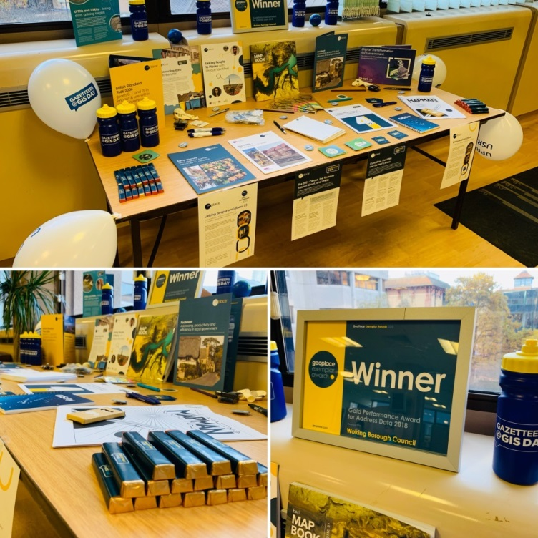

*Every council may use a variety of different software regarding Geographic Information Systems, but this year we are focusing in promoting the new version of:*

* [***Woking MapViewer***](http://ewokplus/business/strategy/business/gis/apps/Pages/Woking-MapViewer.aspx)*- This system enables everyone in the Council to view, produce and print maps for anywhere in the Borough. The new version was launched on 29th of September 2018.*

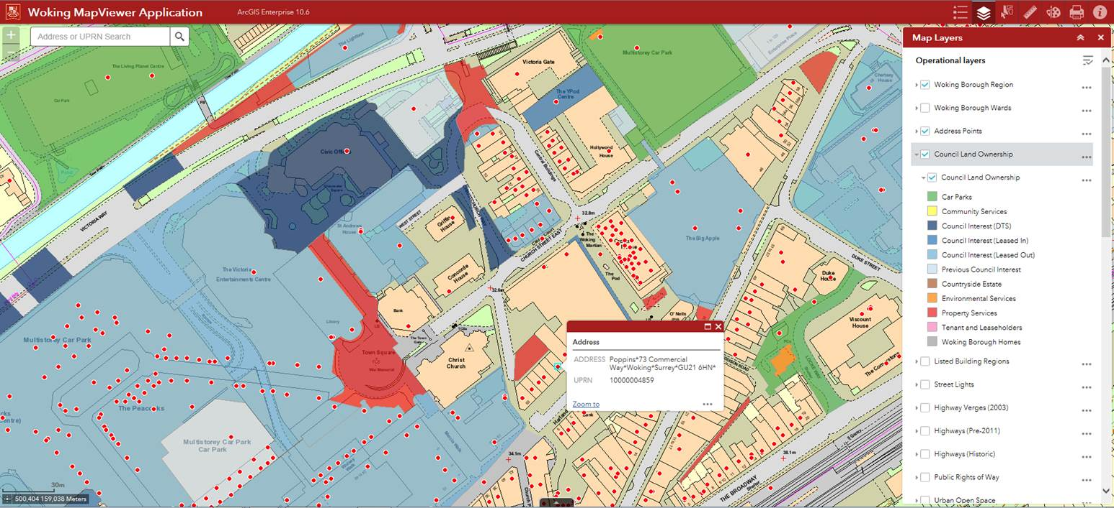

*Unless you are a very techy person or happen to be part of a local authority, not everyone is aware of the existence of an* ***Address gazetteer****. This unfamiliar phrase is used to describe where every property/building/dwelling is officially registered: a database. Back in the days where no technology was available this information was actually stored in a simple book and the person in charge of this book was the* ***Gazetteer Officer****.*

*As you can imagine the Gazetteer and the GIS systems match perfectly together because they allow an instant source of address and locational information in one single step. The emergency services use the details in the gazetteer to determine resources for example, the type of building or land and its use. Also the location details, if these are incorrect, means valuable time can be lost in responding to an emergency call.*

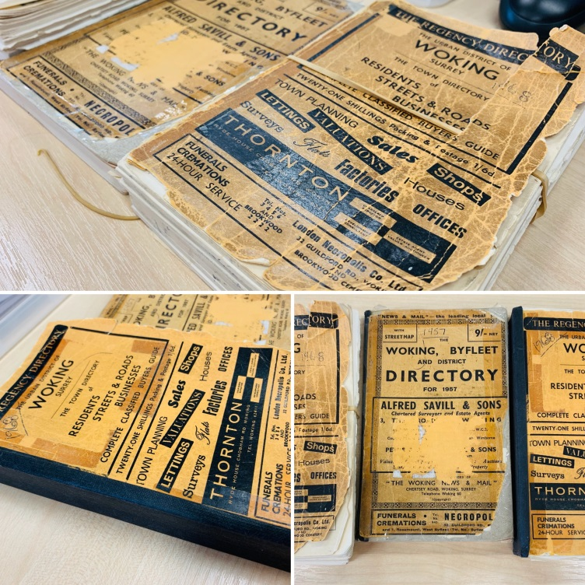

*The importance of using new means to register and store addresses has become a vital task for all local authorities. As we do not have a book anymore, we now identify “the book of addresses” as the* ***Local Land and Property Gazetteer*** *(LLPG) which holds a record for each piece of land, property and object in the Borough. Each record in the LLPG has a* ***unique property reference number*** *(UPRN) which is used in other systems such as Civica, TLC (Total Land Charges) and eXpress (Electoral Registration). This information is also provided in a larger dataset which is called the* ***National Address Gazetteer****, where all the United Kingdom addresses are stored.*

*The reason why we use a UPRN is to ensure the address is only held once in any system. For example in Electoral Registration this means a household will only have the ability to vote once. Each UPRN record can tell you information like what type of dwelling is (for example: a detached house, a flat, a terraced house), what the planning history is, if there are any current planning applications being considered, if it’s licensed for services – and more! It also holds any previous addresses for that property.*

*Street naming and numbering is a statutory function which the Council must provide. All new addresses and changes to addresses have to be issued and registered officially under the street naming and numbering process. These official addresses are then entered or amended in the gazetteer ensuring the accuracy of the detail is instant for all users.*

*If you would like more information on the use of GIS and LLPG at Woking this is available on* [*ewokplus*](http://ewokplus/business/strategy/business/gis/Pages/GIS-Day.aspx) *and the corporate website.*

[*GISday official site*](https://gisday.com/)

[*Gazetteer@GIS Day*](https://www.geoplace.co.uk/news-events/gazetteers-gis-day)

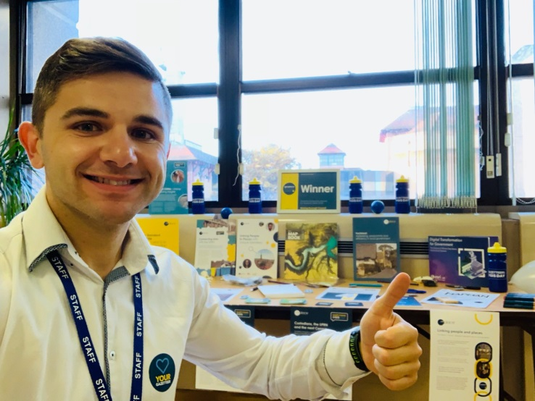

*Your Gazetteer Officer: Andrea Bollella*

*Third floor, South Wing of the Civic Offices*